Renju lesson on June 21, 2001

Hello all! Welcome to Online Renju Class. Today we will have shorter lesson.
Those who have regularly attended the lessons know that we are about to finish the study of this 12th move. We have only one more branch to study. Then we will go on with those new 12th moves.
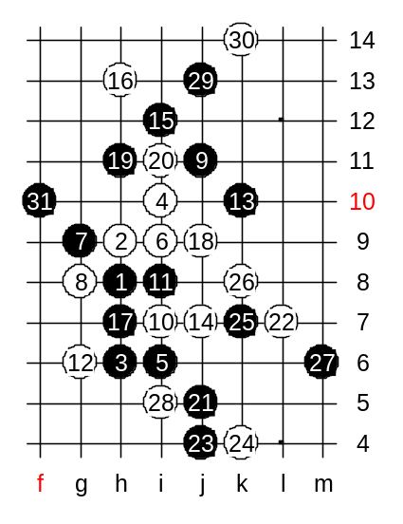
Today we will study 18-j9. This is the last choice of 18th move that we are going to discuss. 19-h11 is a good move since white cannot win on the right side. Now we have chosen h11, lets try to block it somehow. Any suggestions? One thing is sure – if white attacks then white position becomes even worse. Move 20-i11 is the best, I think. Black can choose between more than 8 different 21st move here. I personally prefer the black continuation through j5 point.
22-L7 is a brave move. Black can choose between passive k7, or active j4. I am not sure about the outcome of j4 variant. Shall we try it?
Black has to be careful now and avoid 3x3 trap. Maybe it is good timing for black to go 25-k7 now. F10 – improvisation. Typical black development – having prepared the attacking material on the right side, black continues attack on the left side, by using the source of right side material.
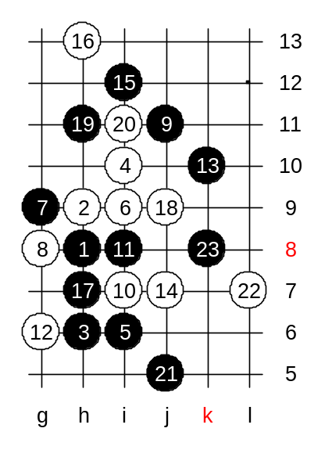

This is the medium level homework. Please find the white win.

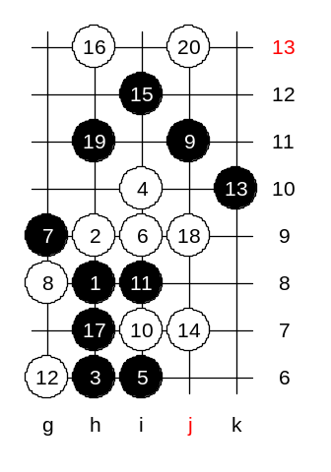

This is the advanced level homework. Please find the black win.

